The civil Engineering Department, of SSVPS’S B S Deore Polytechnic Dhule was established in year 1983. Initially, the diploma offered in ‘Construction Technology’ but later on it was revised to ‘Civil Engineering’. Along with lectures, practical’s, field visits and expert lectures, the faculty of department is also active in testing and consulting work as well.
The Civil Engineering Department comprises of well equipped laboratories of various subject such as listed below :-
- Engineering Mechanics,
- Strength of Materials,
- Mechanics of Structures,
- Concrete Technology,
- Geotechnical Engineering,
- Soil Mechanics,
- Model Lab,
- Civil Engineering Workshop,
and classroom with all learning facilities for the students, it has departmental library as well flourished with all the books covering entire curriculum of the student for First Year, Second Year, Third Year Students.
The Civil Engineering Department meet the challenge by combining new technologies with fundamental principles of classical Civil Engineering Technologies. Project sites for Second & Third year are also selected that students get complete ideas for working in the field. Special site visits are arranged to actual construction sites for practical acquaintance of the students. Also the material testing & mix design facilities are use by almost all nearby government & private agencies. Also the Department has complicated planning, designing of a BOT projects, construction of bypass to Karmala Town on SH141 & a Bridge on Mangi Nala, The project is successfully completed.

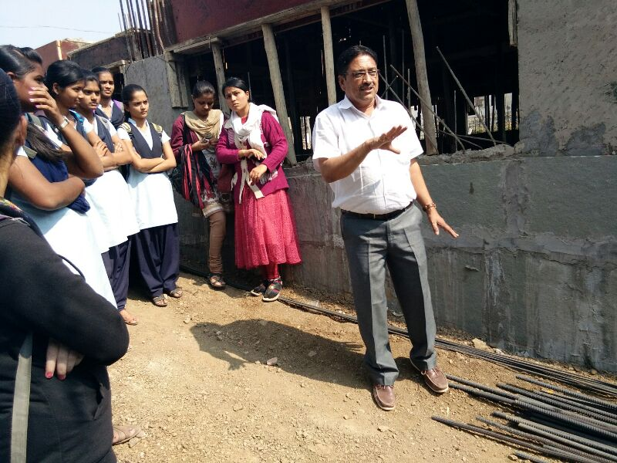
Various field visits undertaken under various subjects indulging the knowledge of field construction practices in the students
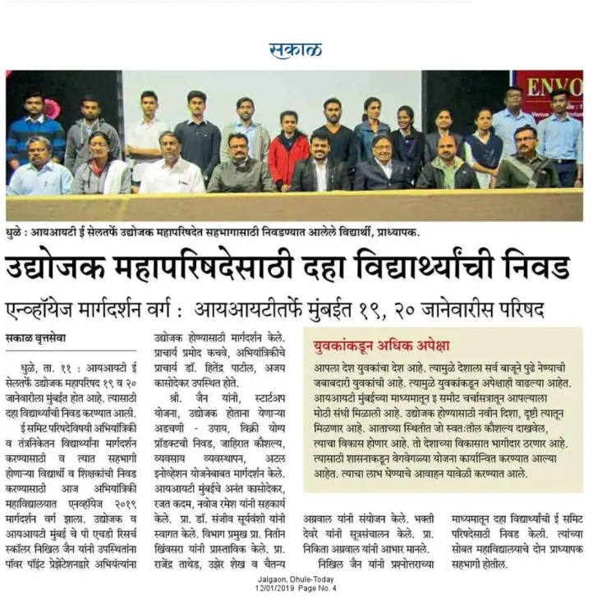
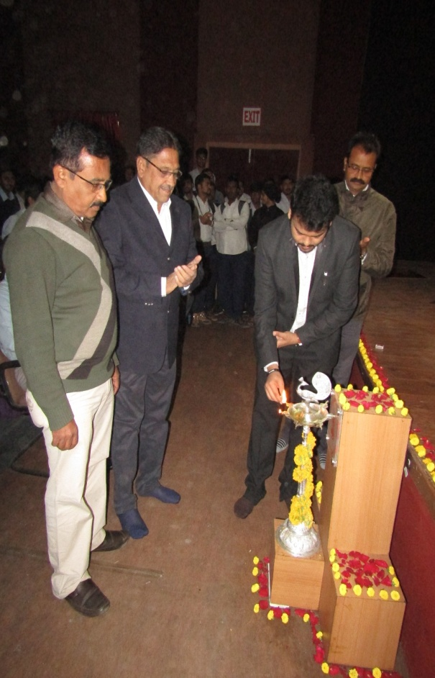
E Summit expert lecture organized by civil department in college auditoriums

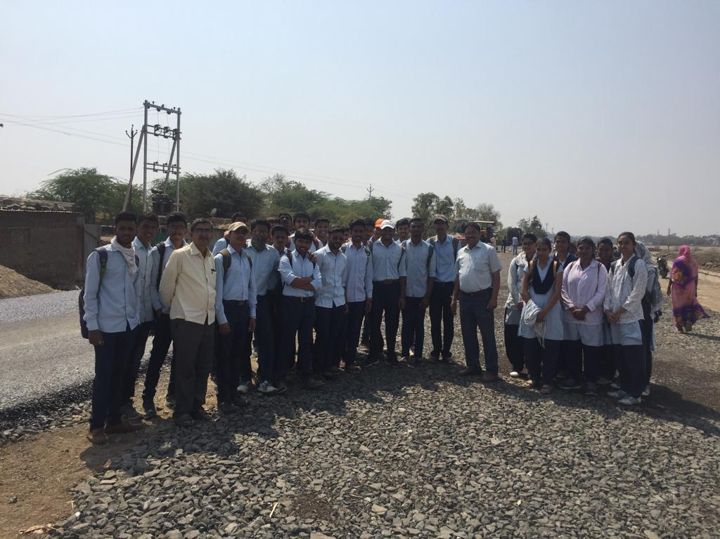
Site visit of TYDC students at WBM road site near Kanushri mangal karyalay
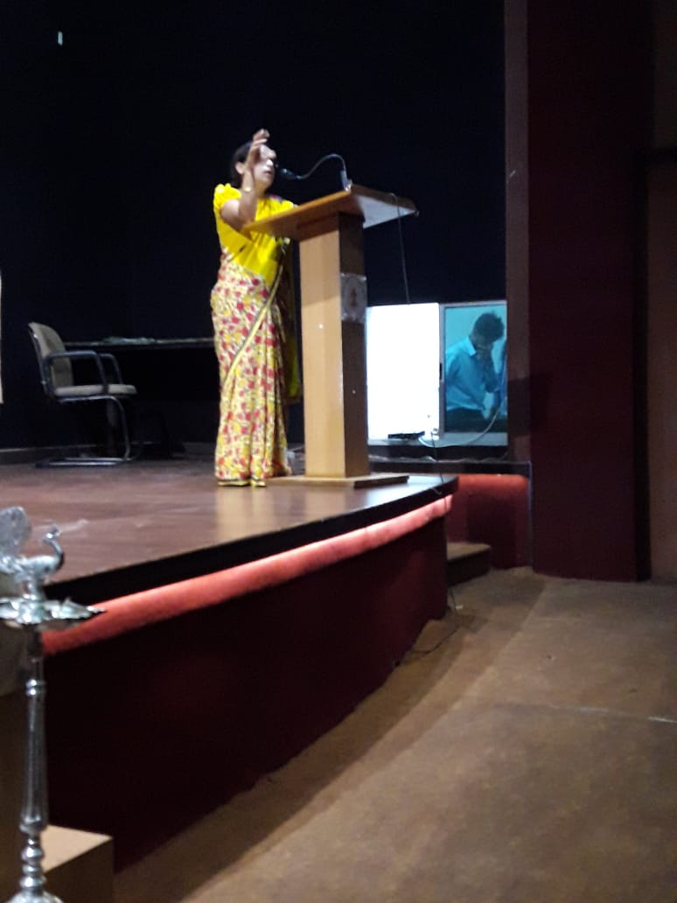
Guest lecture conducted by Dr Anisha Patil about their health issues for girls

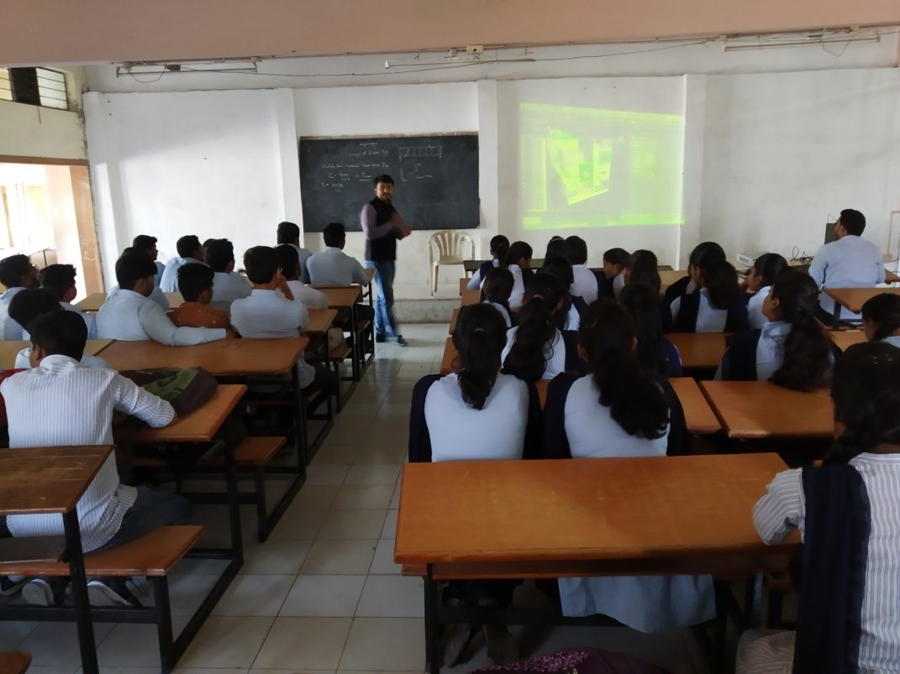
Expert lecture on Software for drafting by Er. Bhavesh Sharma
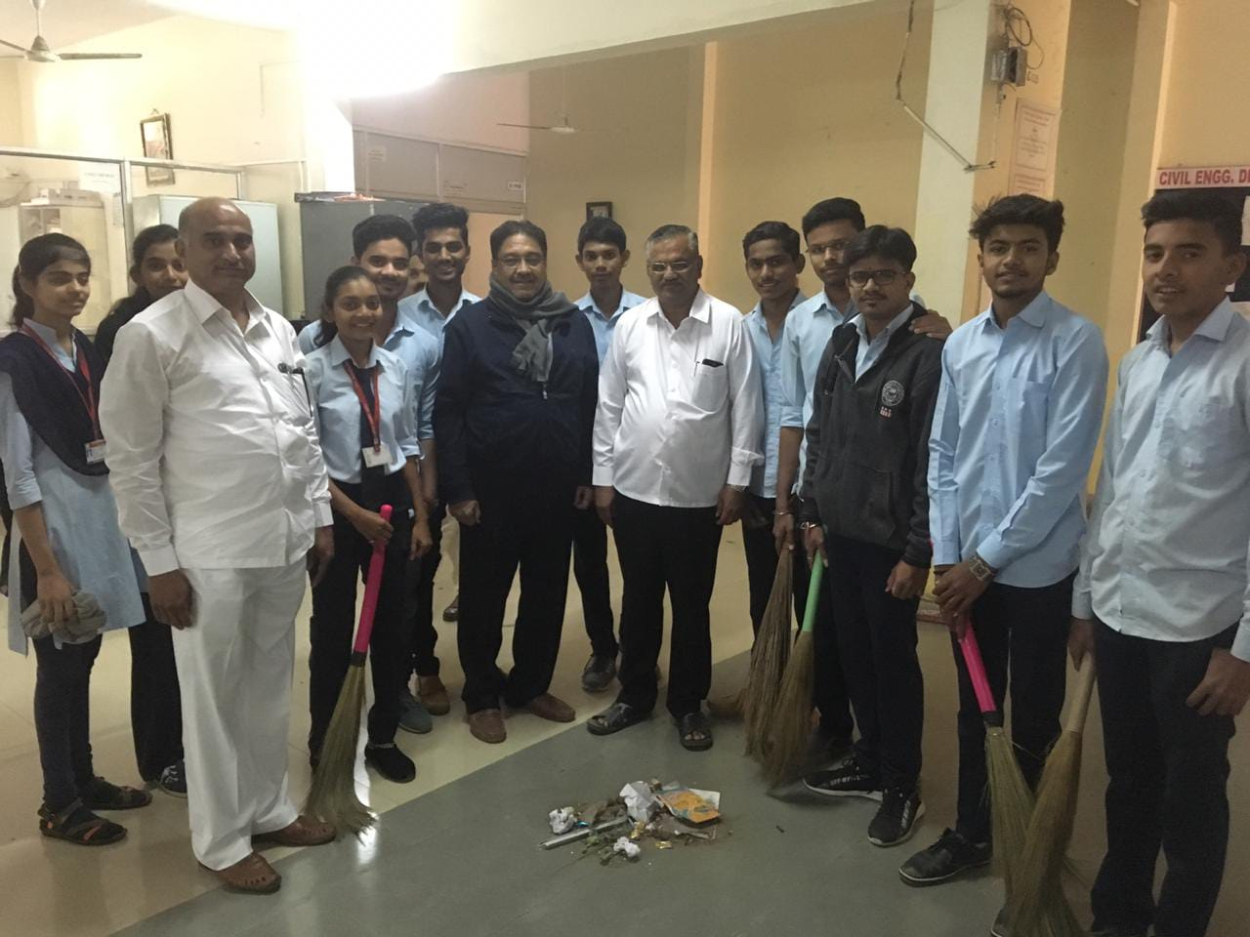
Swatchhata Abhiyaan done in civil dept on the occasion of Republic day
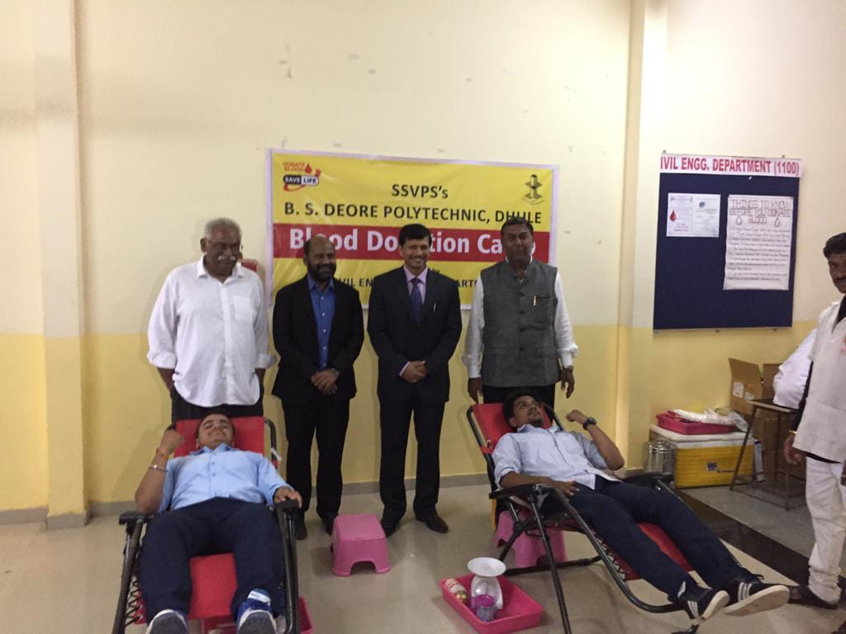
Blood donation camp organized by Civil Dept on the occasion of Engineers day
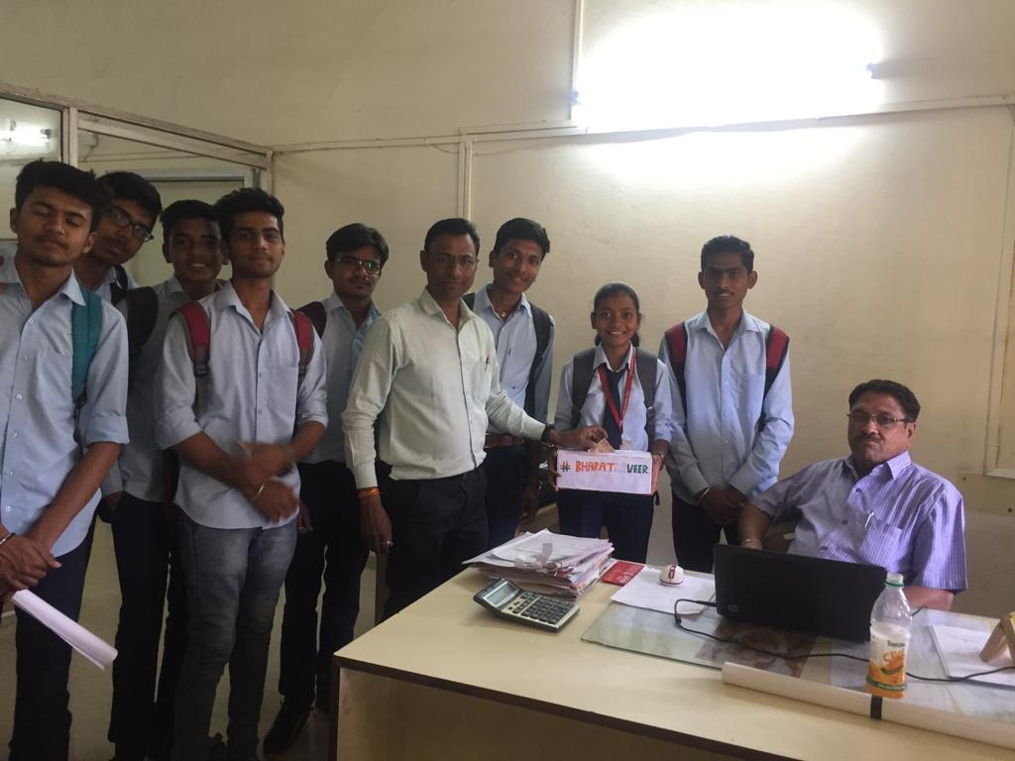
Donations collected by civil dept for serving as an helping hand to the Pulkwama martyrs

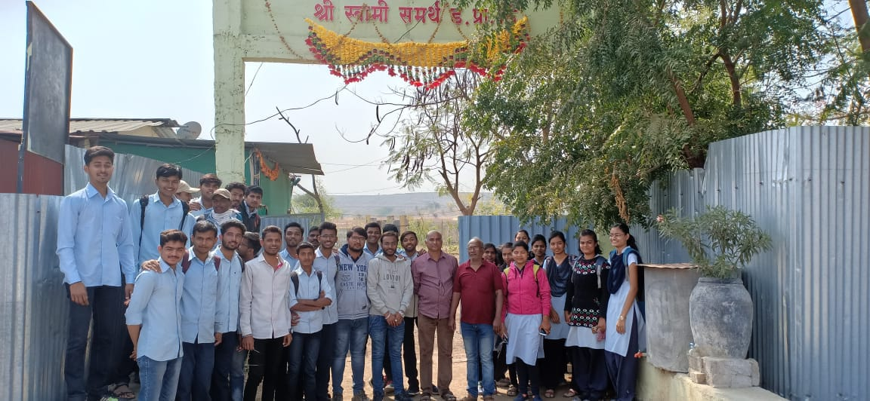
Solid waste managemenbt site visit for TYDC Students
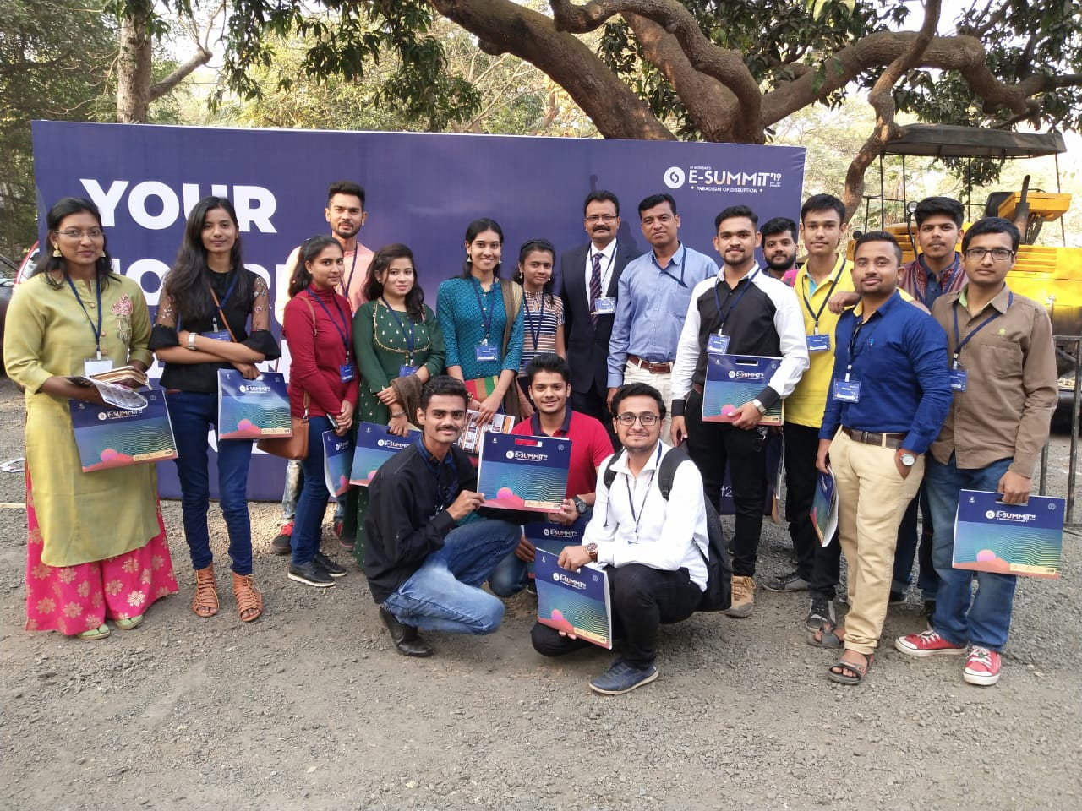
Attending E- SUMMIT Workshop at IIT Powai Bombay

