Personalityv Development Program Yoga Sation
(Mechanical Department)

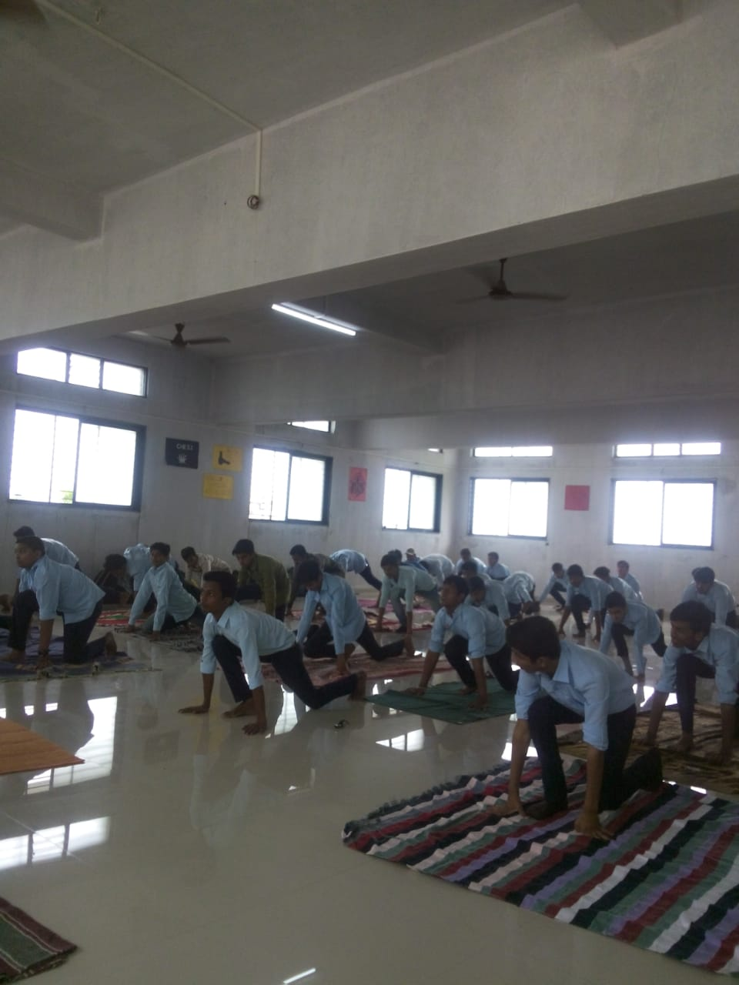
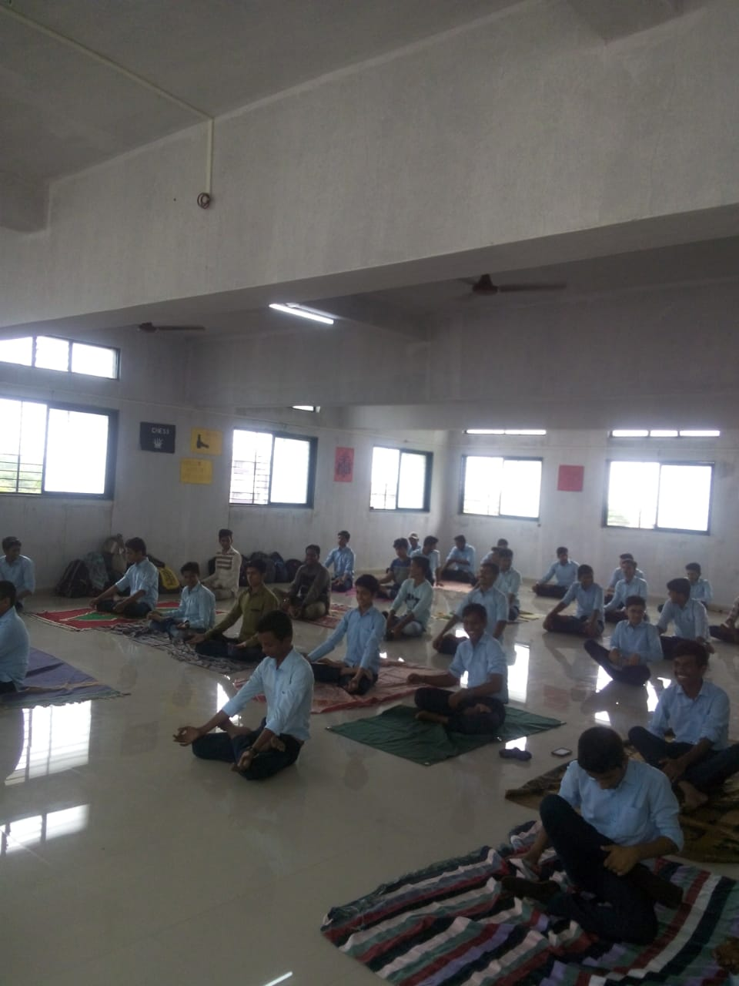

Personality Development Psychometric Lecture
(Mechanical Department)

